CERTIFICACIONES DATABRICKS
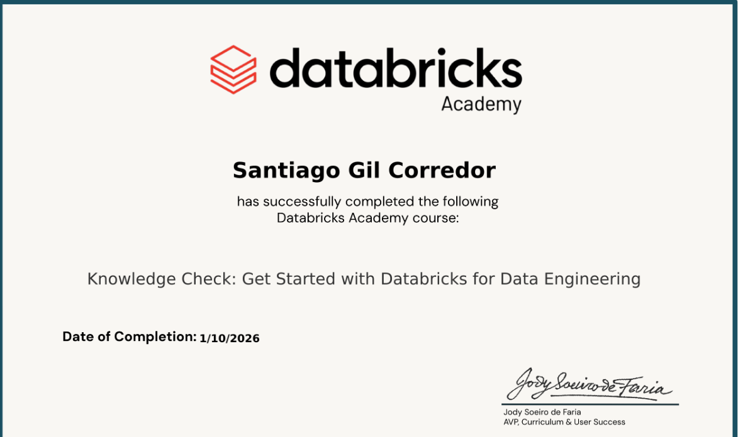
https://www.linkedin.com/in/eduin-santiago-gil-corredor-5a027b264/overlay/Certifications/703807298/treasury?profileId=ACoAAEDS3IgBAfNka0Gg9SBkBQO8OIu56WDSPdY

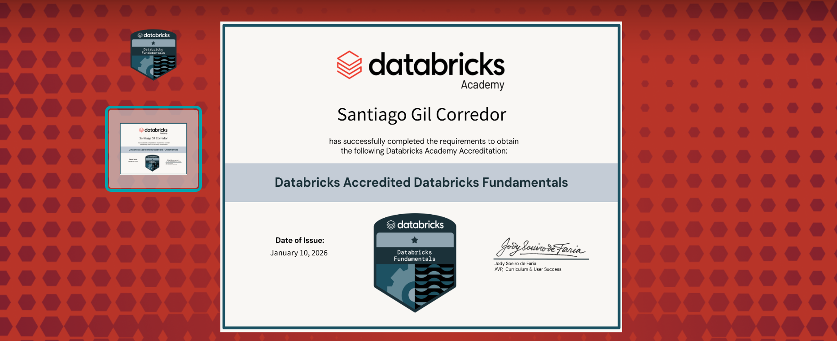
https://credentials.databricks.com/688e8108-c8bf-4364-99a9-cf6170dfcd71#acc.qiGPxyN6

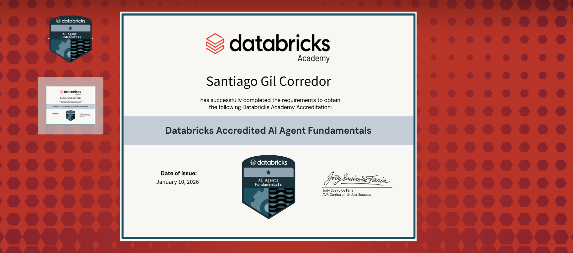
https://credentials.databricks.com/2ce8fa1b-d250-48d3-a02f-fd759d057c87#acc.GYguEcF3

